**NATIONAL ACADEMY OF SCIENCE AND TECHNOLOGY**

Affiliated with National Examination Board

Uttar Behadi-04, Dhangadhi, Kailali, Sudurpaschim Province



A Field Visit Report

on

**“**One Day Educational Tour**”**

**Submitted in partial fulfillment of the requirements for the Grade 11 Science in Computer Science**

**SUBMITTED BY**

Amrit Pant

UNDER THE GUIDANCE OF

Er. Harendra Bikram Shah

Lecturer Computer Science, NAST

SUBMITTED TO

Department of Science,

National Academy of Science and Technology

**2022-2023**

**ACKNOWLEDGEMENT**

Any achievement, be it scholastic or otherwise does not depend solely on individual efforts but on the guidance, encouragement, and cooperation of intellectuals, elders, and friends. we would like to take this opportunity to thank them all.

First, we would like to thank the NAST for providing us with all the requirements for our project.

We are grateful to acknowledge the guidance and encouragement that has been given to us by **Er. Harendra Bikram Shah, Lecturer**, Computer Science, NAST, Dhangadhi, has rendered valuable assistance and guidance.

We also extend our thanks to the entire faculty of the **Department of Science,** NAST, Dhangadhi, who have encouraged us throughout the course of the project.

Last but not least, we would like to thank our family and friends for their input in improving the project.

| **Name: Amrit Pant** | **Roll Number: 04** |
| --- | --- |
|  |  |
|  |  |
|  |  |
|  |  |

**DECLARATION**

We, Amrit Pant, Abhishek Mal, Bharat Bhandari, and Mahendra Bikram, students of the Computer Science of Science group of NAST affiliated to NEB, hereby declare that the work undertaken in this Educational tour entitled “**One-day Educational Tour**” is the outcome of our own effort and is correct to the best of our knowledge. This work has been accomplished by obeying social ethics. It contains neither materials published earlier or written by another person/people nor materials which have been accepted for the award of any other degree of the school or other institution, except where due acknowledgment has been made in the document

| AMRIT PANT  2079/09/17 | ABHISHEK MAL |
| --- | --- |
|  | 2079/09/17 |
|  |  |
| BHARAT BHANDARI  2079/09/17 | MAHENDRA BIKRAM SINGH  2079/09/17 |
|  |  |
| : |  |

**CERTIFICATE**

This is to certify that the report entitled “**FEILD VISIT OF RADIO NEPAL AND NEPAL TELEVISION AT BUDHITOLA**” is a report of the work carried out by **AMRIT PANT** under the guidance and supervision of Er. Harendra Bikram Shah for the partial fulfillment of secondary school grade XI certificate level degree of Computer Science by the National Examination Board.



To the best of our knowledge and belief, this work embodies the work of the candidates themselves, has duly been completed, fulfills the requirement of the ordinance relating to the Grade XI degree of the school, and is up to the standard in respect of the content, presentation, and language for being referred to the examiner.

| **Er. Harendra Bikram Shah** | **Mr. Krishna Bhandari** |
| --- | --- |
| Lecturer, Computer Science | HOD, Science |
| NAST | NAST |
| Dhangadhi, Kailali | Dhangadhi, Kailali |
| ………… | ………… |
| **Signature** | **Signature** |

………………………...

Mr. Upendra Bahadur Bam

**Principal**

**NAST**

***Table of Contents***

| **S.N.** | **Contents** | **Page No.** |
| --- | --- | --- |
| 1. | Introduction………………………………………………………...   * 1. Definition | 1-5 |
| 2. | Objectives……………………………………………………….. | 6 |
| 3. | Methodology ………………………………..................................... | 6 |
| 4. | Findings………………..…………………………………………… | 7-8 |
|  | Conclusions and Recommendations………………………………..  References………………………………………………………… | 9 |

**Chapter 1**

**INTRODUCTION**

**Radio Nepal**

Radio Nepal was established on 2 April 1951. Initially, the transmission covered a duration of 4 hours and 30 minutes through a 250 Watt SW transmitter. Over the years, Radio Nepal has strengthened its institutional capacity considerably and diversified itself in terms of program format, technical efficiency, and coverage. Radio Nepal airs programs on Medium Wave and FM frequencies. Regular broadcasts cover a duration of 24 hours every day which includes approximately 4 hours of province broadcasts from 14:15 hrs. to 18:00 hrs.

**Nepal Television**

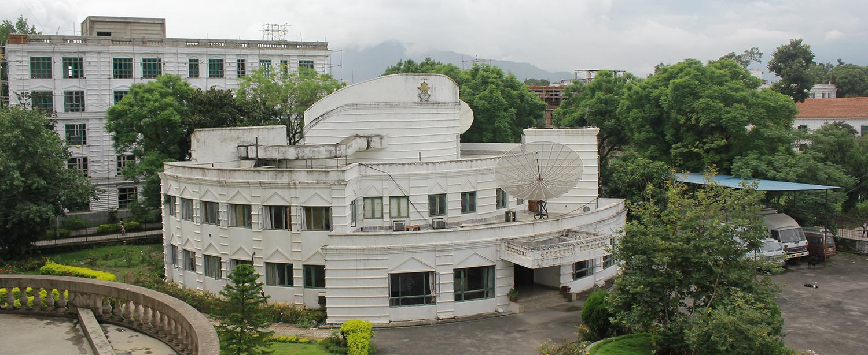

(NTV) is the Nepalese national public state-controlled television broadcaster. It is the oldest and most-watched television channel in Nepal. The news broadcast at 8:00 PM is the channel's most popular show, followed by comedy programs such as Sakkigoni, Mundre Ko Comedy Club, and Meri Bassai.

**Repetition Station**

Those Stations which amplify the single from the satellite in order to provide better quality to the audience are known as the repetition station. These stations are used to increase single of radios and TVs.

**Buditola Repetition Station**

This Repetition lies in the Sudurpaschim Province, Kailali District, Godwari Municipality, It place was used as an army base camp during the moist civil war, But After the Civil war It was established as a repetition station. Currently, it broadcasts Radio Nepal and Nepal Television from the station. It is a fully government-owned Repetition Station.

* 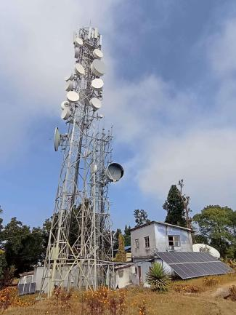

**Chapter 2**

**OBJECTIVES**

* To observe the working of Radio Nepal Repeating Tower

We have

* To observe the working of Nepal Television Repeating Tower

**Chapter :3**

**METHODS OF STUDY,**

First of all, we fixed the date and place for the educational tour. We collected primarily as well as secondary data by using various methods. We followed the following methods to collect the primary data about Radio Nepal and Nepal Television Repeating station.

* **Presentation session**

Our Teachers and Engineers at the repetition station explained the working of the station.

* **Observing methods**

We also collected secondary data by consulting library books, browsing the internet, etc.

**\*\*\*\*\*\*\*\*\*\*\*\*\*\*\*\*\*\*\*\*\*\*\*\***

**Chapter :4**

**FINDINGS**

We have observed the Different Machines which work together:

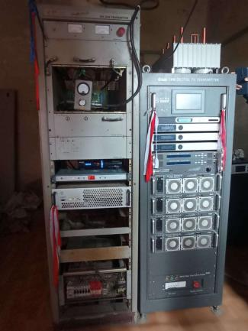

This beast (picture of the right side) is a *1kw Digital TV transmitter* which is capable to transmit signals over 9 districts. It's made by a Chinese company BBEF. The Digital Transmitter was not working at the time of writing so they were using an analog transmitter. You know why it's not working.

The machine on the left side of the picture is an Analog transmitter. Which is capable of transmitting analog signals. Obviously, It produces more heat, and it's slower than a digital one.

**Working Methodology**

Working Principle is very simple. A beautiful reporter from Kathmandu telecasts a show then they send it to the Satellite. The Repetition Station Receives the signals from Satelite and Amplifies them using the device shown in the above figure. The Amplified singles are sent using the tower(figure on the first page). The locals receive the signals and enjoy the program

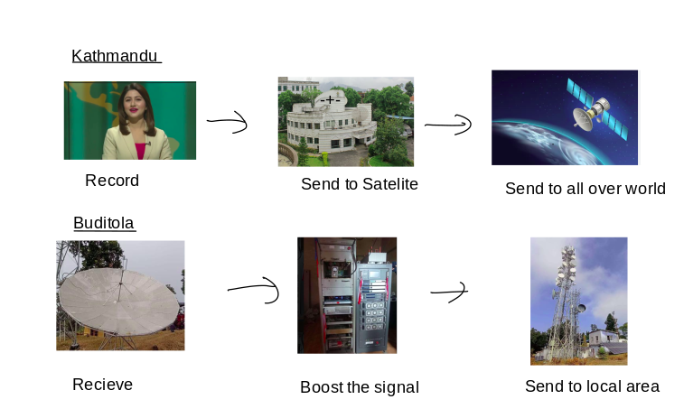

*NOTE: THIS IS OVER SIMPLIFIED VERSION OF WHAT ACTUAL HAPPENS BEHIND THE SCENE*

**CONCLUSION AND RECOMMENDATION,**

In Conclusion, We have learned a lot about TV signals, radios, and stuff. I think this place is losing its value because most people are now watching youtube and TikTok. There are also a lot of management issues with the repetition station. Which needs to resolve. Currently, It's a nice place to understand about Tvs and radio but I think in the future this place might turn into a museum because the types of equipment are super old, with no new innovation. No focus of the government. I hope that day never comes because I love this place.

**REFERENCES**

[1] Nepal Television Budhitola Station Kailali Sudurpaschim province, Nepal

[2] <https://ntv.np>

[3] Budhitola local people

[4] wikipedia.com

[5] google.com

[6] youtube.com